**The Evidence**

[](https://www.harmreductionadvocate.com/educational-resources/event-one-8katj)

[**Educational Resources: Introduction - A New Era**](https://www.harmreductionadvocate.com/educational-resources/event-one-8katj)

* Mon, Nov 11, 2024  Tue, Nov 11, 2025

Introduction To Psychedelic Education

[View Event →](https://www.harmreductionadvocate.com/educational-resources/event-one-8katj)

[](https://www.harmreductionadvocate.com/educational-resources/event-five-7mcnj-xdlse)

[**Spiritual Wellness**](https://www.harmreductionadvocate.com/educational-resources/event-five-7mcnj-xdlse)

* Mon, Nov 11, 2024  Tue, Nov 11, 2025

Energetically well…

[View Event →](https://www.harmreductionadvocate.com/educational-resources/event-five-7mcnj-xdlse)

[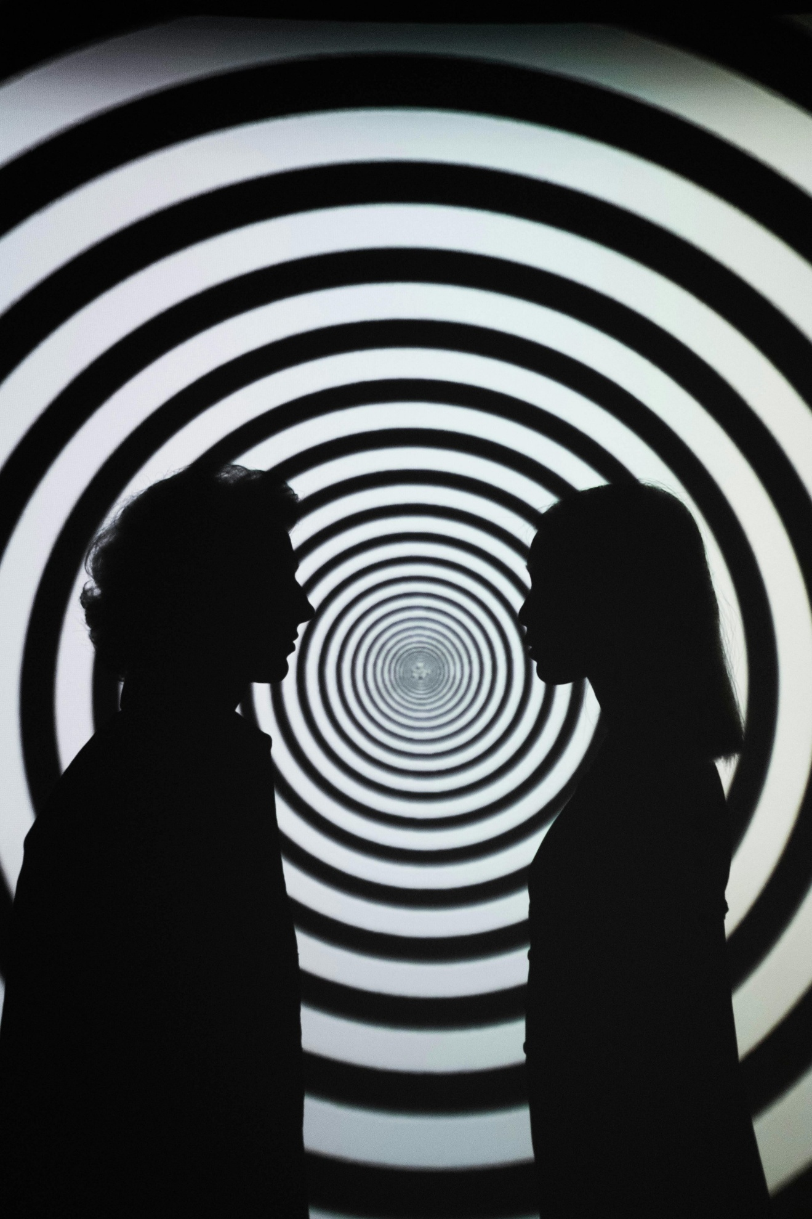](https://www.harmreductionadvocate.com/educational-resources/event-one-8katj-69lhb)

[**Wellness of the ‘Well’**](https://www.harmreductionadvocate.com/educational-resources/event-one-8katj-69lhb)

* Mon, Nov 11, 2024  Tue, Nov 11, 2025

Psychedelics could benefit society and humankind…

[View Event →](https://www.harmreductionadvocate.com/educational-resources/event-one-8katj-69lhb)

[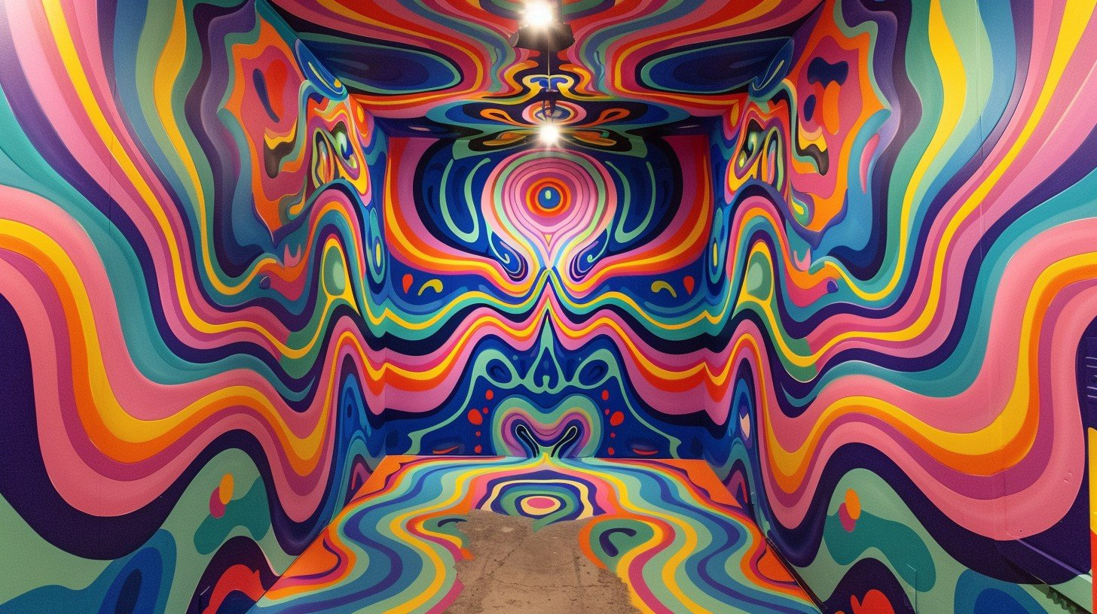](https://www.harmreductionadvocate.com/educational-resources/event-one-8katj-bst5y)

[**PTSD**](https://www.harmreductionadvocate.com/educational-resources/event-one-8katj-bst5y)

* Mon, Nov 11, 2024  Tue, Nov 11, 2025

Trapped in anxiety, PTSD, generalized anxiety disorder, complex trauma, childhood trauma, or all of the above?

[View Event →](https://www.harmreductionadvocate.com/educational-resources/event-one-8katj-bst5y)

[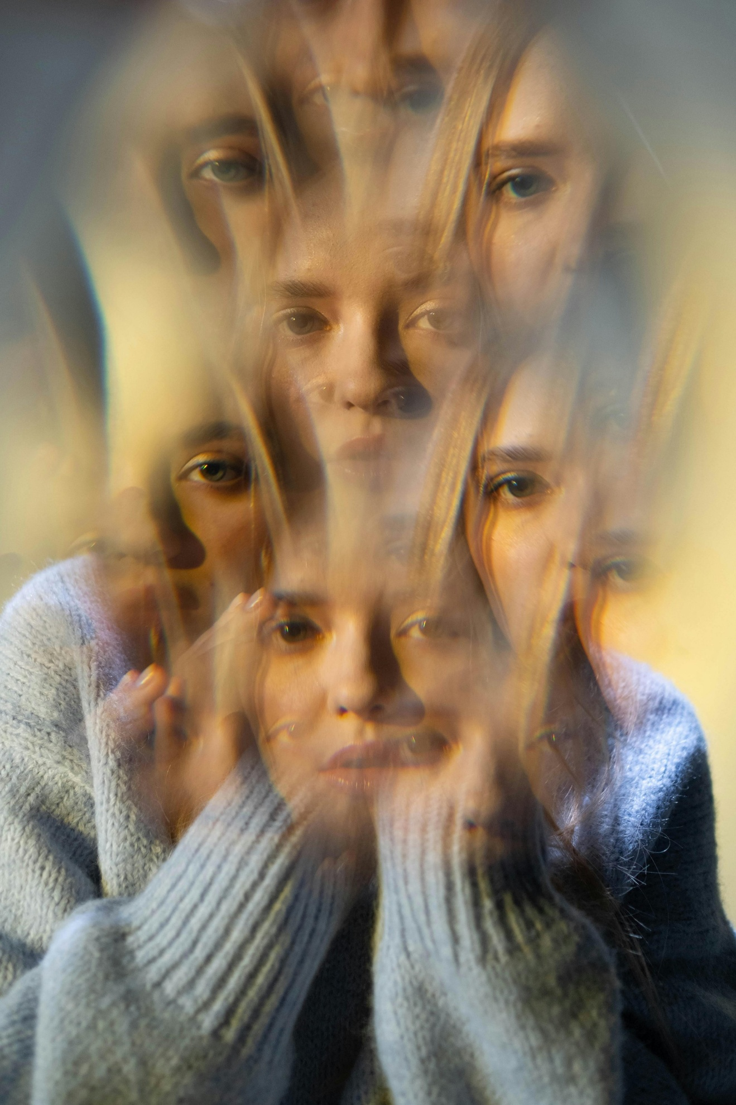](https://www.harmreductionadvocate.com/educational-resources/event-five-7mcnj)

[**Substance use Disorder**](https://www.harmreductionadvocate.com/educational-resources/event-five-7mcnj)

* Mon, Nov 11, 2024  Tue, Nov 11, 2025

Escape addiction by understanding yourself…

[View Event →](https://www.harmreductionadvocate.com/educational-resources/event-five-7mcnj)

[](https://www.harmreductionadvocate.com/educational-resources/event-one-8katj-s4scw)

[**Wellness of the Planet**](https://www.harmreductionadvocate.com/educational-resources/event-one-8katj-s4scw)

* Mon, Nov 11, 2024  Tue, Nov 11, 2025

We are part of nature and it is part of us…

[View Event →](https://www.harmreductionadvocate.com/educational-resources/event-one-8katj-s4scw)

[](https://www.harmreductionadvocate.com/educational-resources/event-one-8katj-tzy3n)

[**Physical Well Being**](https://www.harmreductionadvocate.com/educational-resources/event-one-8katj-tzy3n)

* Mon, Nov 11, 2024  Tue, Nov 11, 2025

Heal Body Mind and Soul

[View Event →](https://www.harmreductionadvocate.com/educational-resources/event-one-8katj-tzy3n)

[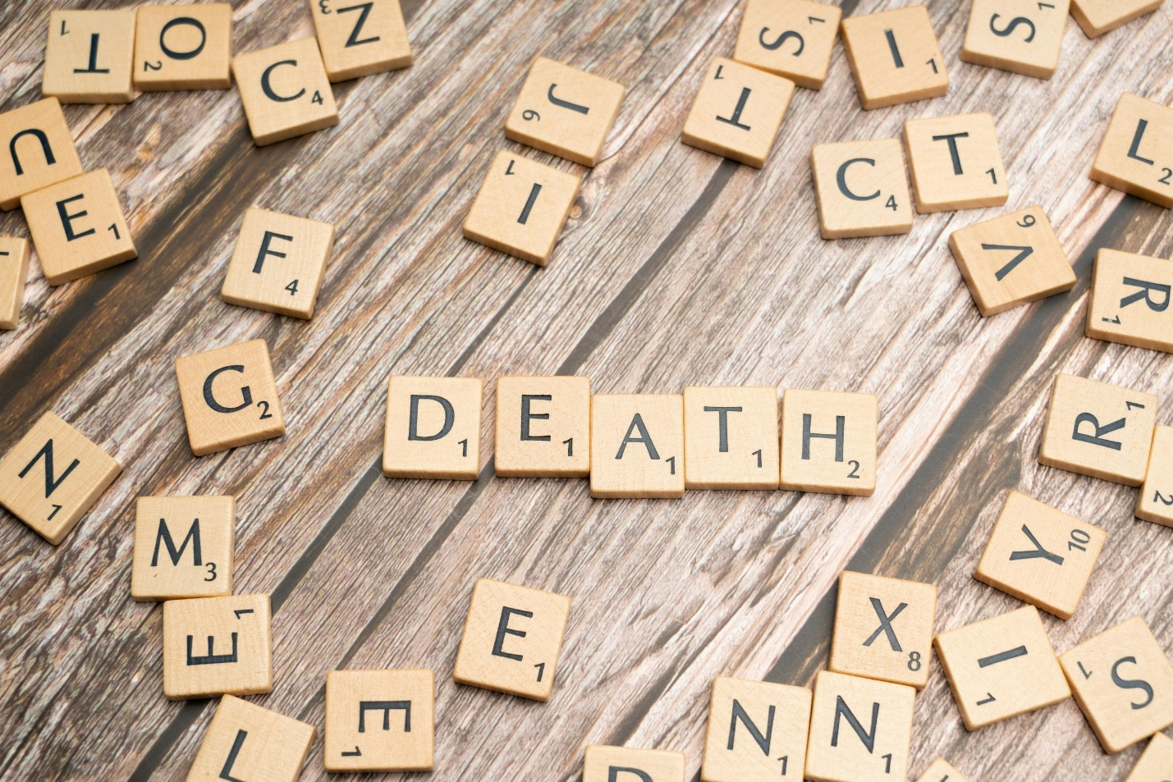](https://www.harmreductionadvocate.com/educational-resources/event-one-8katj-py3ae)

[**End of Life Distress**](https://www.harmreductionadvocate.com/educational-resources/event-one-8katj-py3ae)

* Mon, Nov 11, 2024  Tue, Nov 11, 2025

The true final frontier…

[View Event →](https://www.harmreductionadvocate.com/educational-resources/event-one-8katj-py3ae)